MileStone 1

Name : Himaeswari R K

Employee Id : 761156

Schema Diagram

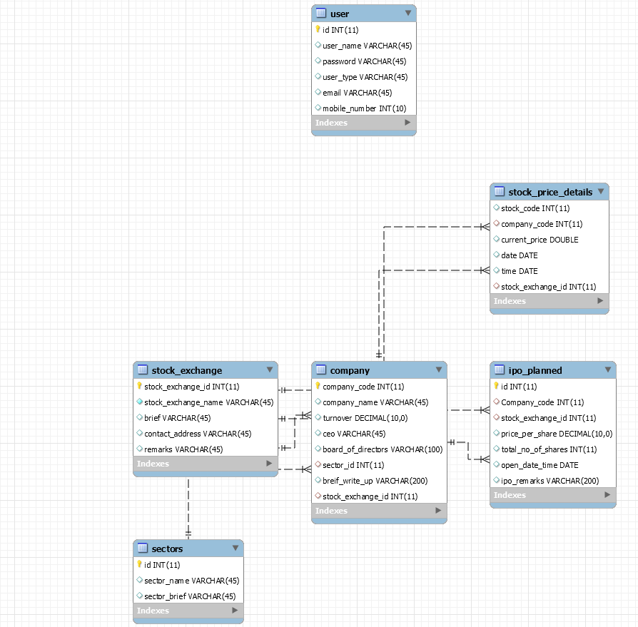

HTML Screens

1) Admin Login Page

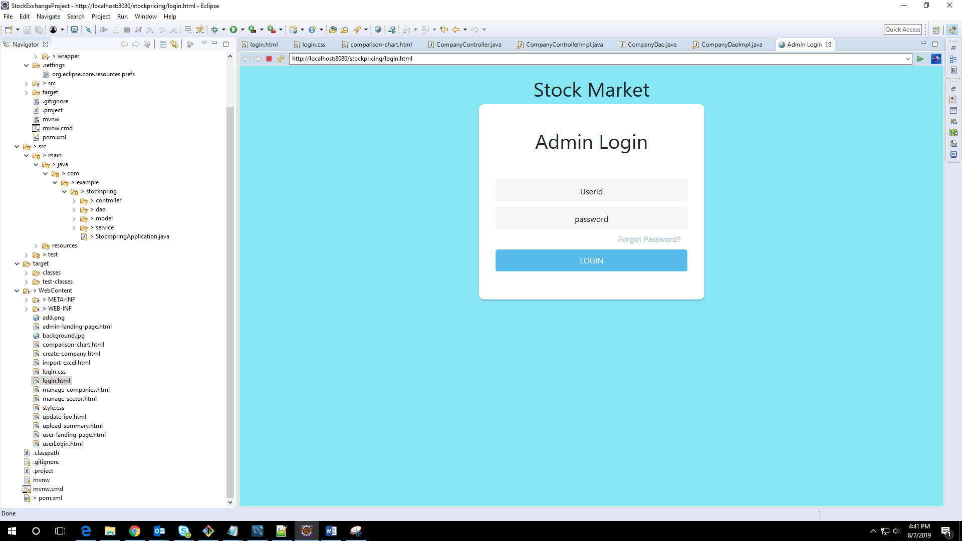

2) User Login Page

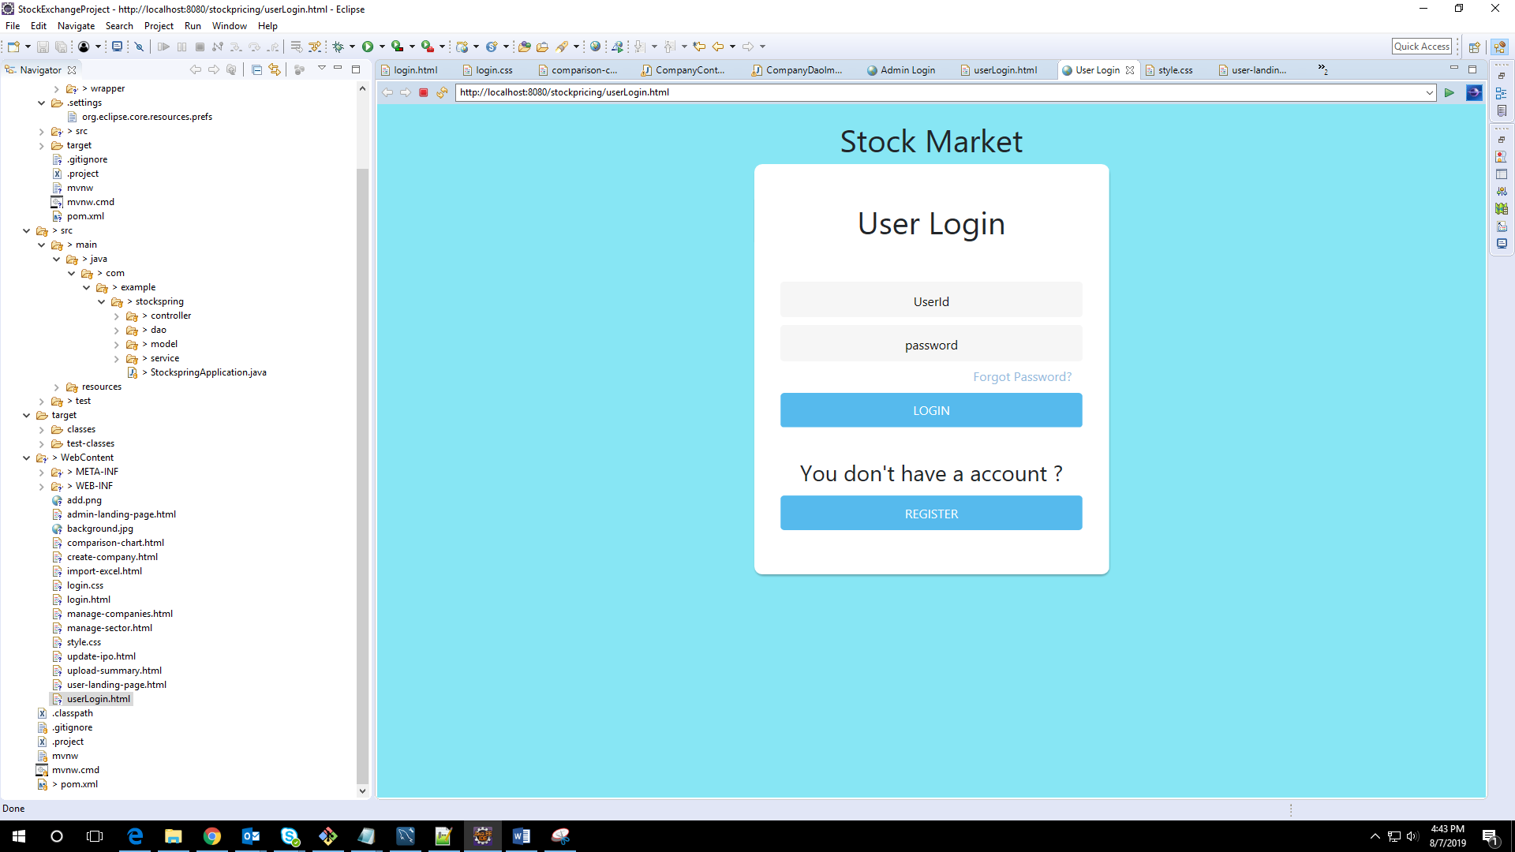

3) Admin Landing Page and Excel Import Page

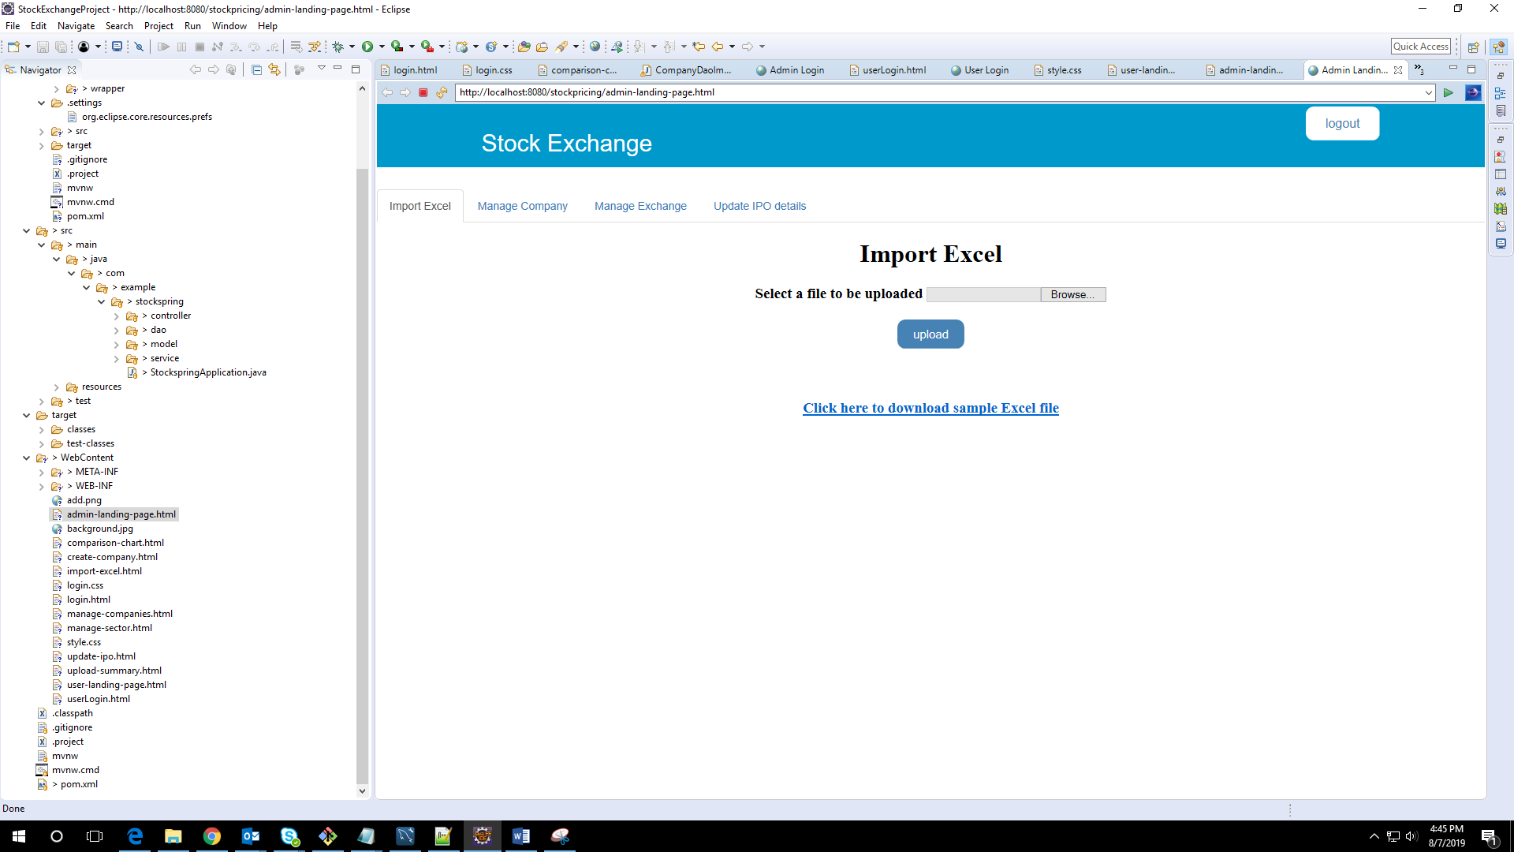

4) User Landing Page and comparison chart Page

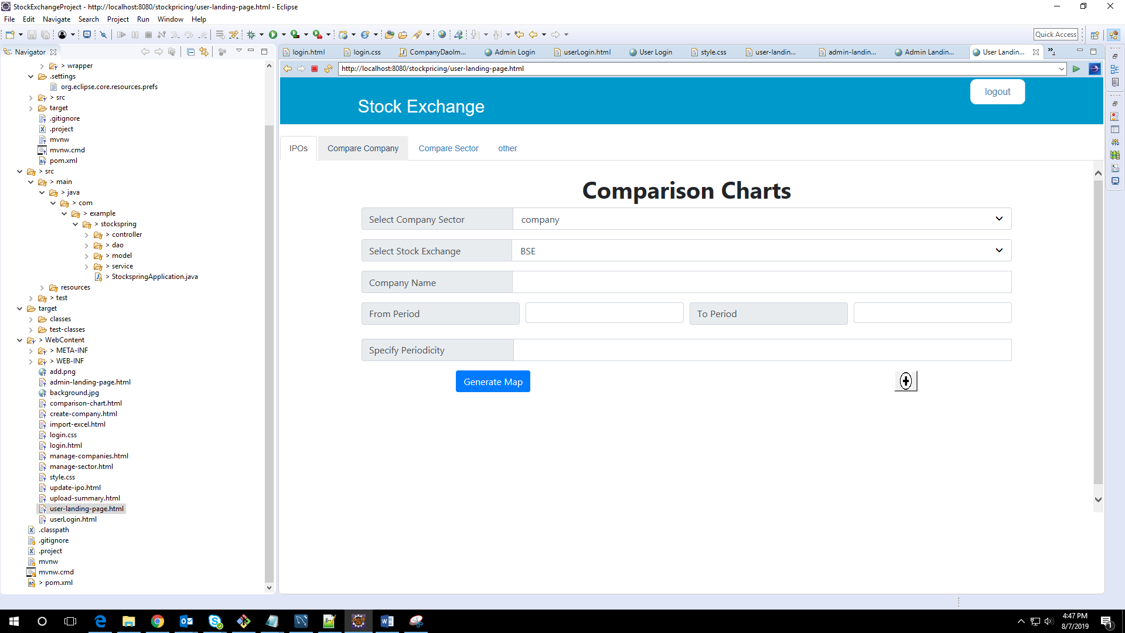

5) Company Creation Page

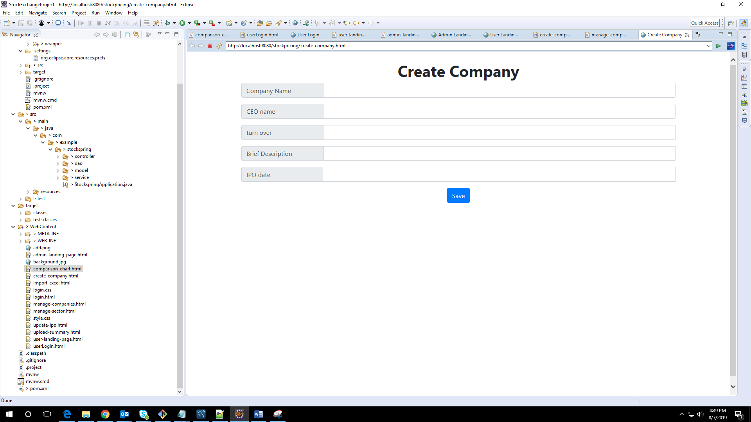

6) Manage Company Page

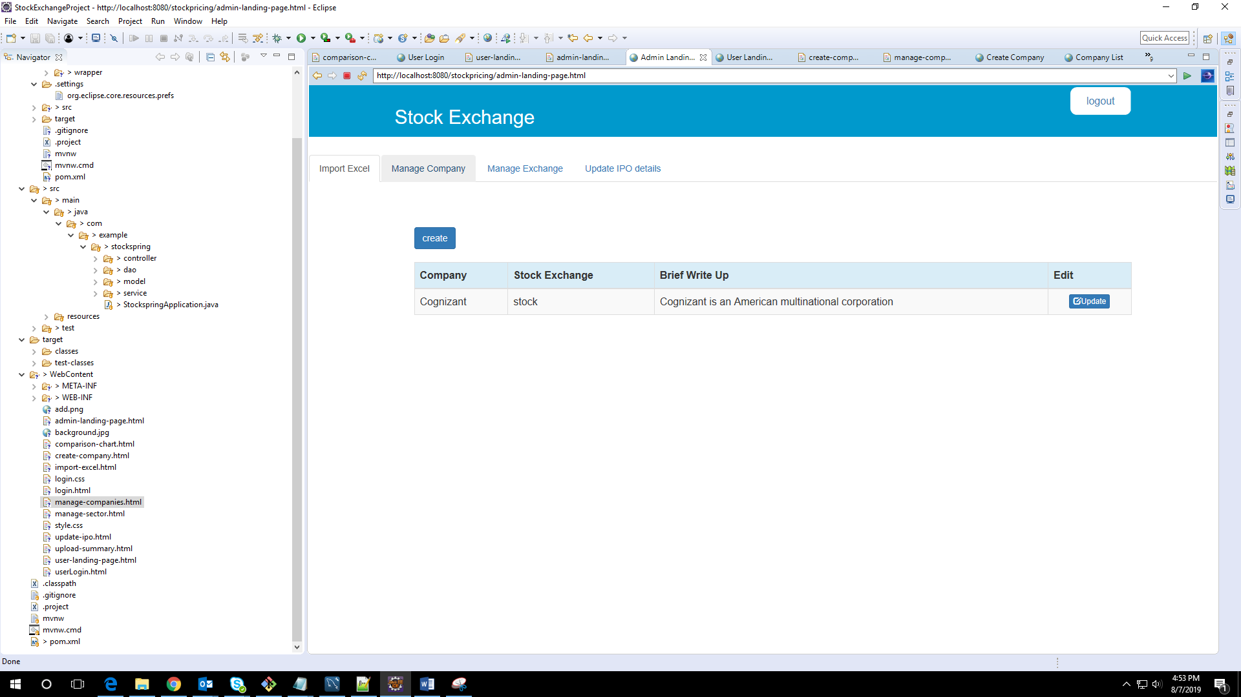

7) Upload Summary Page

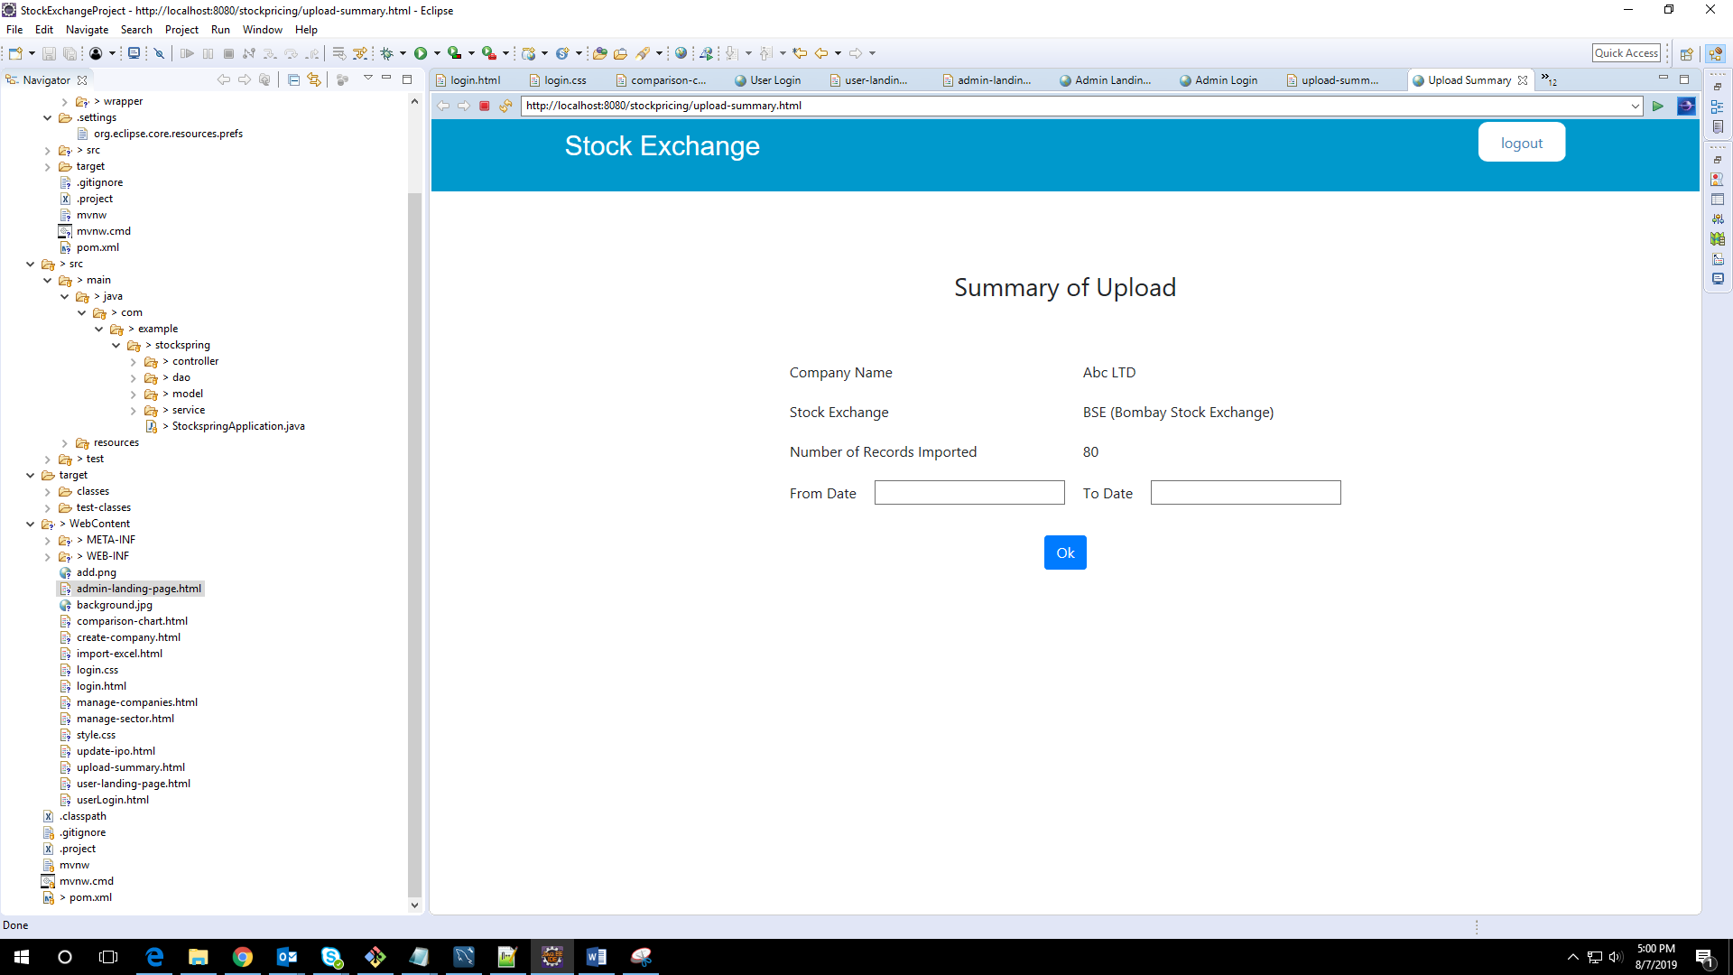

8) Update IPO page

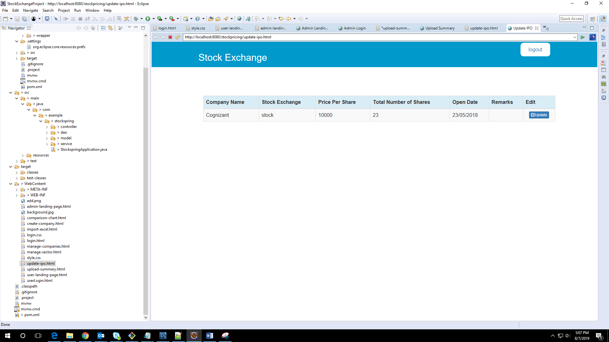

Github link: <https://github.com/Himaeswari/StockExchange>